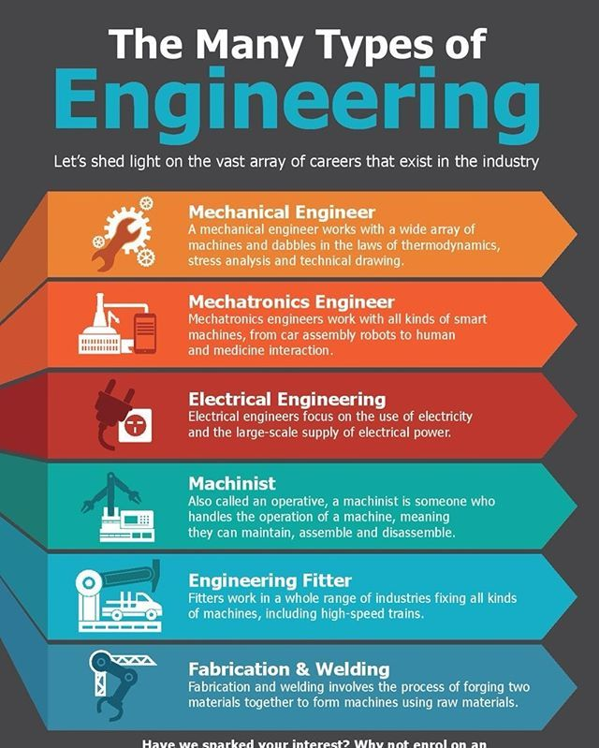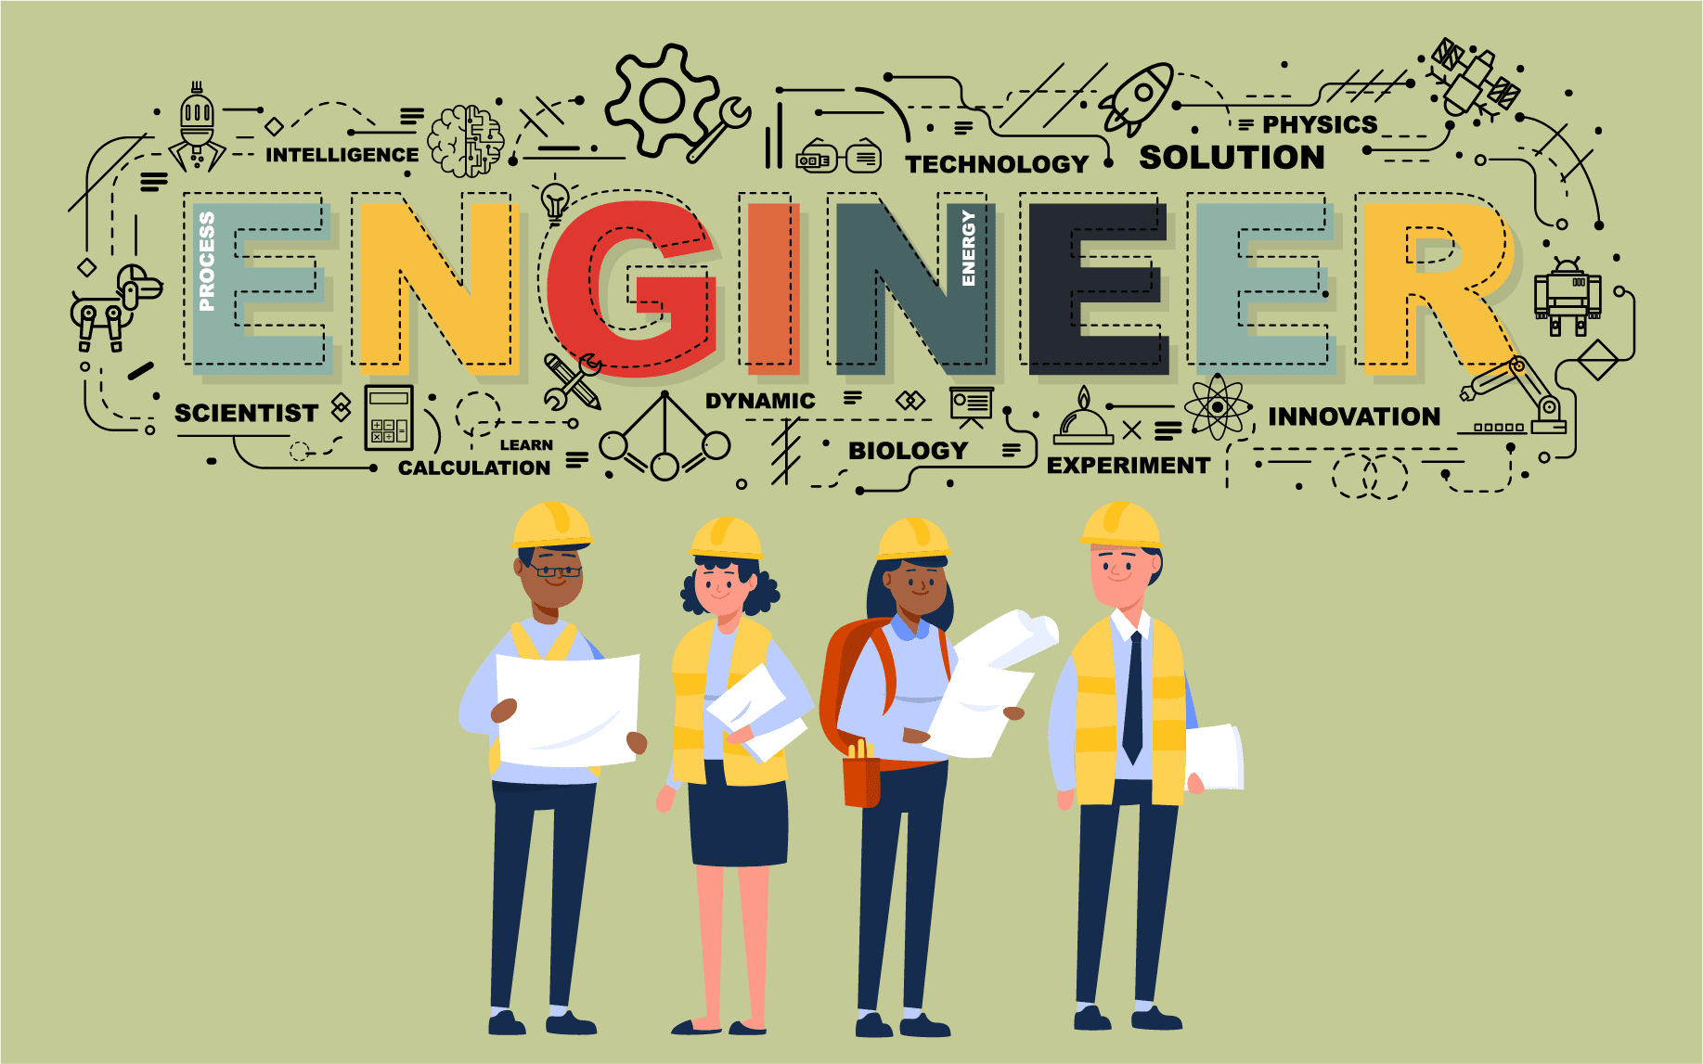

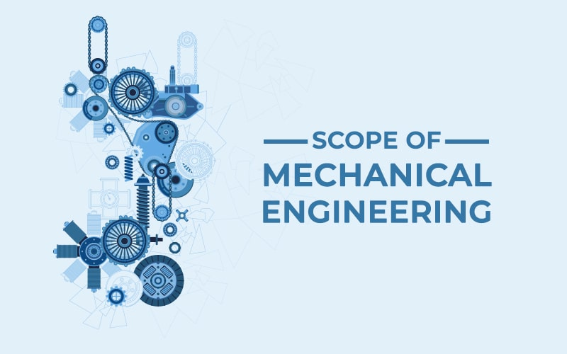***Mechanical engineers design, develop, build, and test. They deal with anything that moves, from components to machines to the human body. The work of mechanical engineers plays a crucial role in shaping the technology and infrastructure that drive our modern world.***

**MECHANICAL ENGINEERS**

**Electrical engineering** is an [engineering](https://en.wikipedia.org/wiki/Engineering) discipline concerned with the study, design, and application of equipment, devices, and systems which use [electricity](https://en.wikipedia.org/wiki/Electricity), [electronics](https://en.wikipedia.org/wiki/Electronics), and [electromagnetism](https://en.wikipedia.org/wiki/Electromagnetism). It emerged as an identifiable occupation in the latter half of the 19th century after the [commercialization](https://en.wikipedia.org/wiki/Commercialization) of the [electric telegraph](https://en.wikipedia.org/wiki/Electric_telegraph), the telephone, and [electrical power](https://en.wikipedia.org/wiki/Electrical_power) generation, distribution, and use.

**ELECTRICAL ENGEENRS**

Electrical engineering is divided into a wide range of different fields, including [computer engineering](https://en.wikipedia.org/wiki/Computer_engineering), [systems engineering](https://en.wikipedia.org/wiki/Systems_engineering), [power engineering](https://en.wikipedia.org/wiki/Power_engineering), [telecommunications](https://en.wikipedia.org/wiki/Telecommunications), [radio-frequency engineering](https://en.wikipedia.org/wiki/Radio-frequency_engineering), [signal vprocessing](https://en.wikipedia.org/wiki/Signal_processing), [instrumentation](https://en.wikipedia.org/wiki/Instrumentation), [photovoltaic cells](https://en.wikipedia.org/wiki/Photovoltaic_cell), [electronics](https://en.wikipedia.org/wiki/Electronics), and [optics](https://en.wikipedia.org/wiki/Optics) and [photonics](https://en.wikipedia.org/wiki/Photonics). Many of these disciplines overlap with other engineering branches, spanning a huge number of specializations including hardware engineering, [power electronics](https://en.wikipedia.org/wiki/Power_electronics), electromagnetics and waves, [microwave engineering](https://en.wikipedia.org/wiki/Microwave_engineering), [nanotechnology](https://en.wikipedia.org/wiki/Nanotechnology), [electrochemistry](https://en.wikipedia.org/wiki/Electrochemistry), renewable energies, mechatronics/control, and electrical materials science.[[a]](https://en.wikipedia.org/wiki/Electrical_engineering#cite_note-1)

Electrical engineers typically hold a [degree](https://en.wikipedia.org/wiki/Academic_degree) in electrical engineering, electronic or electrical and electronic engineering. Practicing engineers may have [professional certification](https://en.wikipedia.org/wiki/Professional_certification) and be members of a [professional body](https://en.wikipedia.org/wiki/Professional_body) or an international standards organization. These include the [International Electrotechnical Commission](https://en.wikipedia.org/wiki/International_Electrotechnical_Commission) (IEC), the [Institute of Electrical and Electronics Engineers](https://en.wikipedia.org/wiki/Institute_of_Electrical_and_Electronics_Engineers) (IEEE) and the [Institution of Engineering and Technology](https://en.wikipedia.org/wiki/Institution_of_Engineering_and_Technology) (IET, formerly the IEE).

Electrical engineers work in a very wide range of industries and the skills required are likewise variable. These range from [circuit theory](https://en.wikipedia.org/wiki/Circuit_theory) to the management skills of a [project manager](https://en.wikipedia.org/wiki/Project_manager). The tools and equipment that an individual engineer may need are similarly variable, ranging from a simple [voltmeter](https://en.wikipedia.org/wiki/Voltmeter) to sophisticated design and manufacturing software.

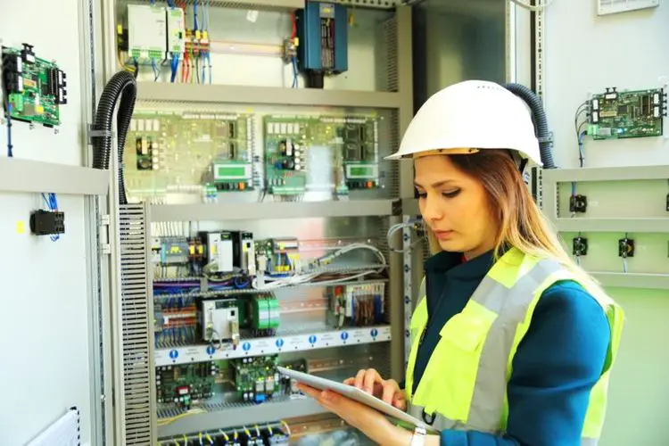 ***mechanisms Mechanical EngineeMechatronics involves the Mecring: hanical Engineering: Mechatronics involves the design and analysis of mechanical systems, such as sensors, actuators, and mechanical structures. This can include anything from robotic arms and automated machinery to consumer products like cameras with auto-focus mechanisms.design and analysis of mechanical systems, such as sensors, actuators, and mechanical structures. This can include anything from robotic arms and automated machinery to consumer products like cameras with auto***

**MECHATRONICS ENGINEER**